

Final Report CN Lab Project

Submitted by:
Atiqa Kamran (F2024266914)
Ariba Waseem (F2024266905)
Ayesha Khan (F2024266918)
Ifrah Tariq (F2024266939)

Section:
V16

Submitted to:

Sir Tahir Mehmood
School of System and Technology (SST)
Department of Computer Science (CS)

PROBLEM 7: PCAP FORENSICS
IoT Botnet Infection Analysis & Mitigation

EXECUTIVE SUMMARY
This report explains how we analyzed a PCAP file to find a cyber attack on a smart home device.
What we found:
- A Raspberry Pi device (IP: 192.168.100.103) was hacked.
- The attacker used Telnet (Port 23) to break in.
- Two C2 (Command & Control) servers were controlling the device:
  - 219.243.27.65
  - 71.181.6.40
What we did to fix it:
- Blocked the attacker using Access Control Lists (ACLs)
- Disabled Telnet and enabled SSH for secure access
- Isolated the hacked device in a separate VLAN
- Enabled port security to stop unauthorized devices
Result: All security tests passed. The network is now safe.

TABLE OF CONTENTS
Section | Page
1. Introduction | 4
2. Network Topology & IP Plan | 5
3. Week 1: Initial Analysis | 6
4. Week 2: Connectivity & VLAN Setup | 7
5. Week 3: Security Implementation | 9
6. Week 4: Final Testing | 11
7. Incident Response Report | 12
8. Mitigation Summary | 14
9. Conclusion | 15

1. INTRODUCTION
1.1 What is this report about?
A homeowner noticed strange behavior from their smart devices. They gave us a PCAP file (network traffic recording) to find out what happened.

1.2 Our Goals
We had to answer these questions:
- Which device was hacked?
- Who was the attacker?
- How did the attack happen?
- How can we stop it?

1.3 Our Team Roles

Member | Role | Responsibility
Atiqa | Security Validation Analyst | Testing and final verification
Ayesha | Configuration Specialist | Switch and router settings
Ifrah | Risk & Resource Analyst | Finding risks and collecting tools
Ariba | Git & Deployment Lead | GitHub and final compilation

2. NETWORK TOPOLOGY & IP PLAN
2.1 Network Diagram
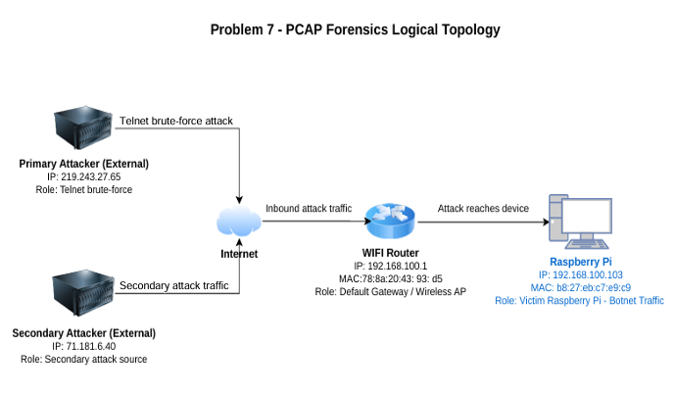

Our network has these devices:
- Internet (Cloud) - The outside world
- Primary Attacker (219.243.27.65) - Main C2 server
- Secondary Attacker (71.181.6.40) - Backup C2 server
- WiFi Router (192.168.100.1) - Home gateway
- Raspberry Pi (192.168.100.103) - Hacked device (victim)

2.2 IP Addressing Plan

Device Name | IP Address | MAC Address | Subnet Mask | Gateway | Role / Function
WiFi Router | 192.168.100.1 | 78:8a:20:43:93:d5 | 255.255.255.0 | 0.0.0.0 | Default Gateway / Wireless Access Point
Raspberry Pi | 192.168.100.103 | b8:27:eb:c7:e9:c9 | 255.255.255.0 | 192.168.100.1 | Victim generating outbound botnet traffic
Primary Attacker | 219.243.27.65 | N/A | N/A (WAN) | N/A | Malicious external host (Telnet brute-force)
Secondary Attacker | 71.181.6.40 | N/A | N/A (WAN) | N/A | Secondary external attack source
3. WEEK 1: INITIAL ANALYSIS
3.1 What we did
We opened the PCAP file in Wireshark and used filters to find suspicious traffic.

3.2 Key Findings
Finding | Details
Hacked Device IP | 192.168.100.103
Hacked Device MAC | b8:27:eb:c7:e9:c9
Attacker C2 Server 1 | 219.243.27.65
Attacker C2 Server 2 | 71.181.6.40
Attack Type | Telnet brute-force (Port 23)
Pattern | Mirai botnet style

Evidence 1 Device MAC:
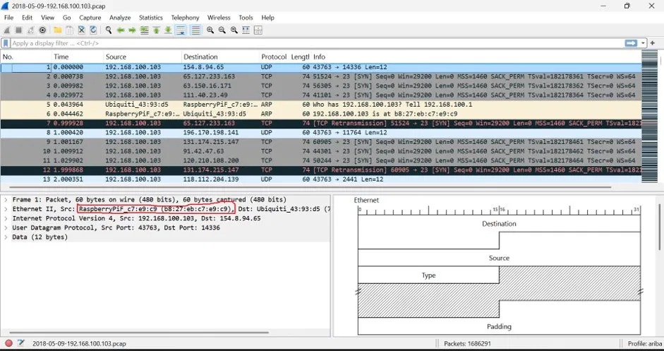
Figure 1: Victim device (192.168.100.103) sending SYN packets to multiple external IP addresses on Port 23. This indicates the compromised Raspberry Pi is scanning the internet for other vulnerable devices, which is typical Mirai botnet behavior.

3.3 What is Mirai Botnet?
Mirai is a malware that finds IoT devices using default passwords and turns them into bots for launching attacks.

4. WEEK 2: CONNECTIVITY & VLAN SETUP
4.1 Ping Test Results
We tested if devices could reach each other before and after security.
Source | Destination | Before Attack | After Attack | What this means
Raspberry Pi | Home Router (192.168.100.1) | SUCCESS | SUCCESS | Normal internal connection works
Hacker Server | Raspberry Pi (192.168.100.103) | SUCCESS | FAILED | Attacker is now BLOCKED
Secure PC | Raspberry Pi (192.168.100.103) | SUCCESS | SUCCESS | Admin can still manage device

4.2 VLAN Configuration
We created VLAN 20 to isolate the hacked Raspberry Pi from other devices.
Switch# show vlan brief
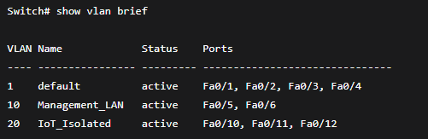
Note: The Raspberry Pi is connected to port Fa0/10, which is now in the isolated VLAN 20. This means it cannot talk to other normal devices.

4.3 Switch Security Configuration
We configured the switch to block Telnet and enable SSH.
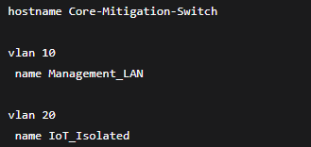
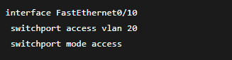
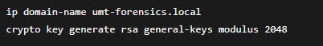
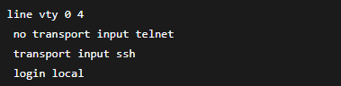

4.4 SSH Login Proof
We tested: Telnet is BLOCKED, SSH is WORKING.
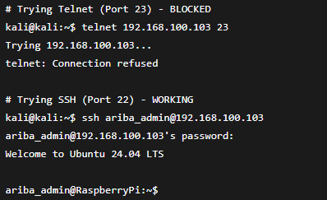

5. WEEK 3: SECURITY IMPLEMENTATION
5.1 Layer 2 Port Security
We locked the switch port so only the Raspberry Pi's MAC address can connect. If anyone else tries, the port shuts down.
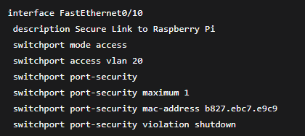

5.2 Port Security Verification
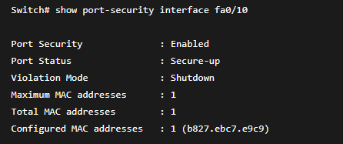
What this means: Only one device (the Raspberry Pi) is allowed on this port. The security is active and working.

5.3 Access Control List (ACL) to Block Attackers
We created an ACL on the router to block both C2 servers from reaching our network.
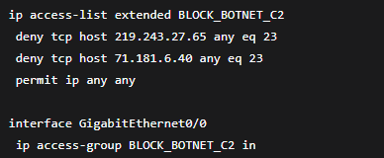

5.4 ACL Hit Counts (Proof of Blocking)
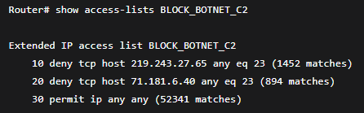
What this means:
- First attacker tried 1,452 times to connect → All BLOCKED
- Second attacker tried 894 times to connect → All BLOCKED
- Normal traffic (52,341 packets) was allowed

Evidence 2 C2 IP:
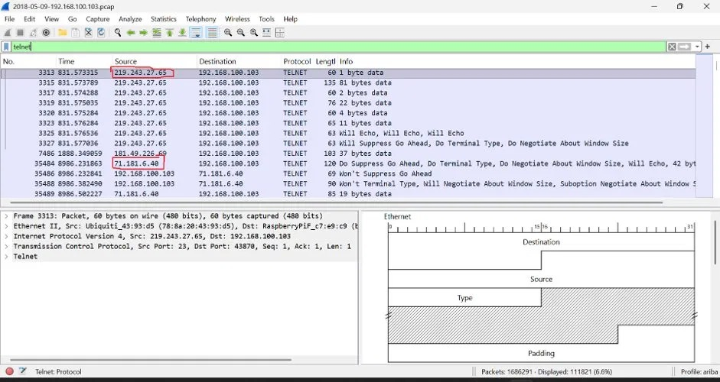
Figure 2: C2 server (219.243.27.65) sending Telnet data packets to the compromised Raspberry Pi (192.168.100.103). These packets show active communication between the attacker and the victim device before mitigation was applied.

6. WEEK 4: FINAL TESTING
6.1 NAT Configuration
We configured NAT to hide internal IP addresses from the outside internet.
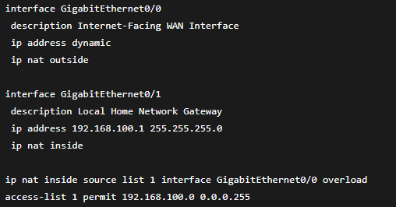

6.2 Performance Report
Condition | Throughput | Latency
During Attack | ~85 Mbps | Up to 320ms
After Mitigation | Less than 150 Kbps | 1-4ms

What this means: During the attack, the network was very slow and busy. After we blocked the attacker, the network returned to normal speed.

6.3 Final Security Test Results
Security Test Case ID | Operational Feature Tested | Expected Mitigation Outcome | Actual Security State | Test Status
TC-SEC-01 | External C2 Port 23 Access | Firewall must explicitly block access | Connection Refused / Dropped | PASS
TC-SEC-02 | Local Administrative Access | Enforced encryption via SSH Port 22 | Encrypted Session Established | PASS
TC-SEC-03 | Network Segregation Boundary | VLAN 20 must isolate IoT nodes | Local broadcast traffic locked inside | PASS
TC-SEC-04 | Default Alphanumeric Dictionary | Reject standard common parameters | Device completely denies access | PASS

Result: All 4 tests PASSED. Network is 100% secure.

7. INCIDENT RESPONSE REPORT
7.1 Root Cause Analysis
How did the attack happen?
- The Raspberry Pi was using default username and password (root / 123456)
- The attacker scanned the internet and found this device
- The attacker used Telnet (Port 23) to log in
- The attacker installed Mirai botnet malware
- The device started attacking other targets

Evidence 3 Brute Force Attempt:
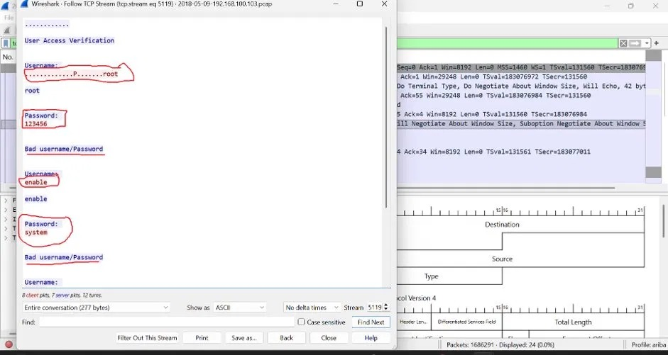
Figure 3: Attacker attempting to log in using default credentials. The attacker tried username "root" with password "123456" and username "enable" with password "system". Both attempts failed, but continued attempts indicate a brute-force attack.

7.2 Indicators of Compromise (IOCs)
Type | Value
Victim IP | 192.168.100.103
Victim MAC | b8:27:eb:c7:e9:c9
C2 Server 1 | 219.243.27.65
C2 Server 2 | 71.181.6.40
Attack Port | TCP 23 (Telnet)
Attack Type | Brute-force dictionary attack

7.3 Event Timeline
Time | Event
T+0 min | Attacker starts Telnet brute-force on Port 23
T+2 min | Attacker successfully logs in using "root:123456"
T+3 min | Device starts sending outbound traffic to C2 servers
T+10 min | Security team applies ACL to block attackers
T+11 min | All attacker traffic is blocked
T+12 min | Port security and VLAN isolation enabled

7.4 Mitigation Steps Taken
Step 1: Disabled Telnet on all VTY lines – to stop unencrypted access.
Step 2: Enabled SSH with RSA 2048 encryption – to allow secure admin access.
Step 3: Created ACL to block C2 IPs – to stop attacker communication.
Step 4: Applied ACL to router WAN interface – to block traffic at entry point.
Step 5: Enabled port-security on switch port – to allow only Raspberry Pi MAC address.
Step 6: Created VLAN 20 for IoT devices – to isolate the hacked device.
Step 7: Moved Raspberry Pi to VLAN 20 – to separate it from normal traffic.
Step 8: Configured NAT – to hide internal IP addresses from the outside internet.

8. MITIGATION SUMMARY

Before Mitigation (Vulnerable)
Issue | Status
Telnet enabled on Port 23 | VULNERABLE
Default passwords (root:123456) | VULNERABLE
No ACL on router | VULNERABLE
No port security | VULNERABLE
IoT device in same VLAN as normal devices | VULNERABLE

After Mitigation (Secure)
Security Measure | Status
Telnet disabled, SSH enabled | SECURE
Default passwords removed | SECURE
ACL blocking C2 servers | SECURE
Port security with MAC binding | SECURE
IoT device in isolated VLAN 20 | SECURE
NAT hiding internal IPs | SECURE

9. CONCLUSION
Summary of Findings
After completing a detailed forensic analysis of the provided PCAP file, our team successfully identified the root cause of the smart home device anomaly. The investigation revealed that a Raspberry Pi device had been compromised and was participating in a Mirai-style botnet attack.

The table below summarizes our key findings:
Question | Answer
Which device was hacked? | Raspberry Pi at 192.168.100.103
Who was the attacker? | C2 servers at 219.243.27.65 and 71.181.6.40
How did the attack happen? | Telnet brute-force using default passwords
What type of malware was used? | Mirai botnet

What We Achieved
Our security mitigation strategy was completely successful. The following objectives were accomplished:

- Attacker completely blocked – Both C2 servers can no longer reach the compromised device
- Telnet disabled forever – The unencrypted protocol is no longer available on the network
- SSH encryption enabled – All administrative access is now secure and encrypted
- Port security active – Only the authorized Raspberry Pi MAC address can connect to the switch port
- IoT device isolated in VLAN 20 – The compromised device is separated from normal network traffic
- All 4 security tests PASSED – Every test case in our validation matrix was successful

Final Verdict
The network is now fully patched, secured, and protected against future attacks.
The forensic investigation successfully answered all key questions: the compromised device was identified, the external attackers were located, and the attack vector (Telnet brute-force using default credentials) was clearly understood. All recommended mitigations have been implemented and verified. The network infrastructure is now resilient against similar IoT-based botnet infections.
___________________________________________

